NAME : NAGA PRUDHVI

REG NO : 192110264

Develop a system using UML for  
Passport Management System; it should verify the passport details of the applicant by the central computer.  
The details regarding the passport will be provided to the central computer and the computer will  
verify the details of the applicant and provide approval to the office. Then the  
passport will issue from the office to the applicant.

USE CASE :

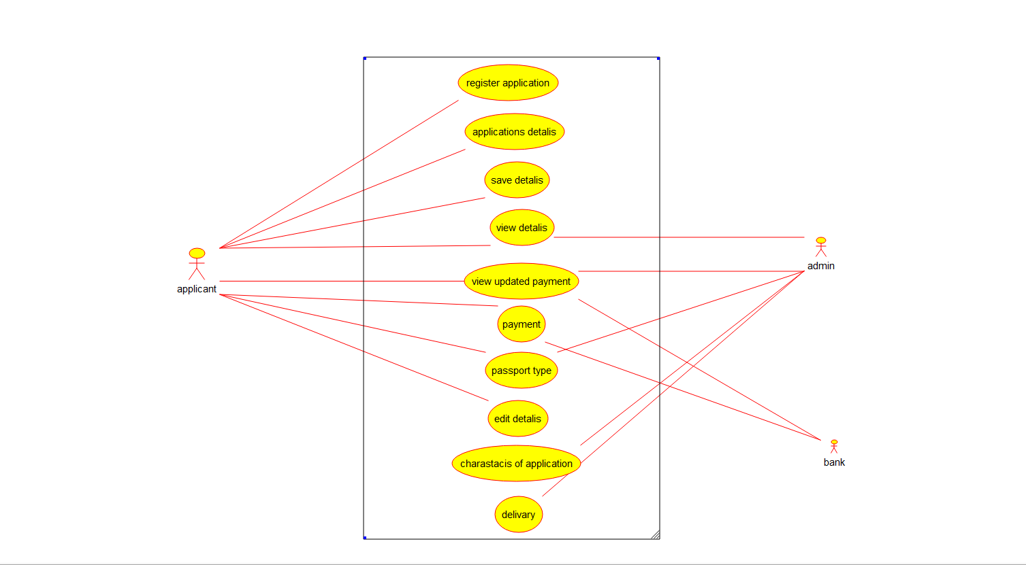

CLASS DIAGRAM :

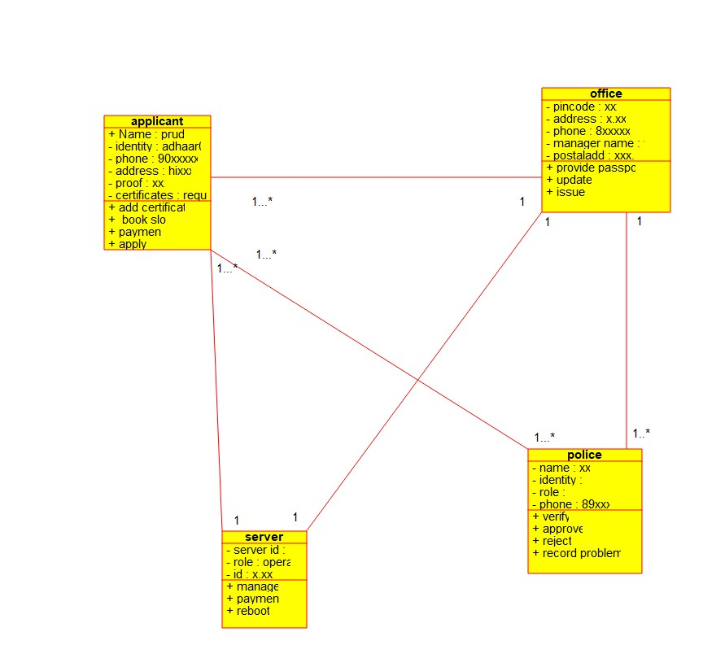

ACTIVITY DIAGRAM : 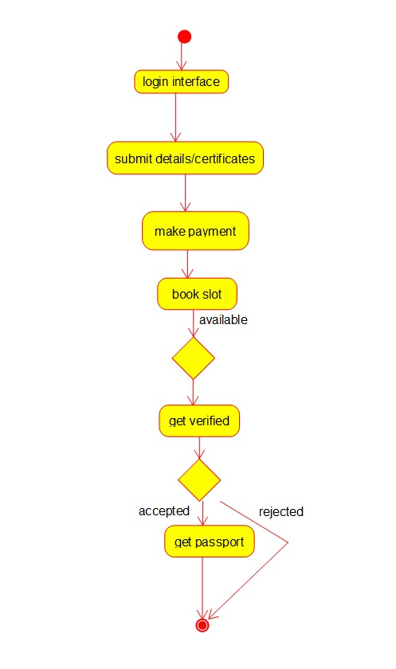

2.     Develop a system using UML for implementing the Book Bank process.  
It should verify the details of  
the student by the central computer. The details regarding the student will be  
provided to the central computer  
through the administrator in the book bank and the computer will verify the details of the student and provide  
approval to the office. Then the books that are needed by the student will issue from the office to  
him.

USE CASE DIAGRAM :

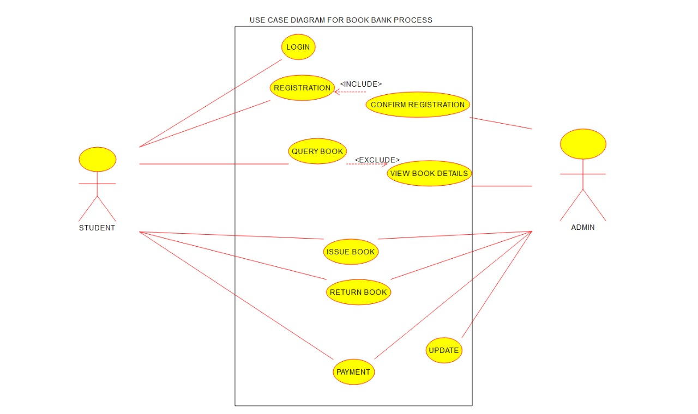

ACTIVITY DIAGRAM :

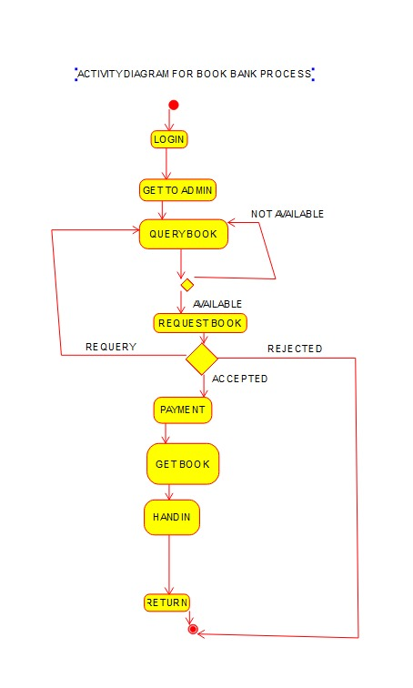

CLASS DIAGRAM :

